npm CLI

💻 What Is npm CLI?
# Source: AI Source: Provided by: [Data Path: Persons Table -> ID Column: 1, Name_En Column: Motasem Essam] -> From: [Chatgpt (GPT‑5 Mini)] on [1/26/2026]
npm CLI stands for Node Package Manager Command-Line Interface — it's the tool you use in the terminal to interact with the npm registry, manage your project’s dependencies, run scripts, and publish packages.

✅ Simple Definition:
# Source: AI Source: Provided by: [Data Path: Persons Table -> ID Column: 1, Name_En Column: Motasem Essam] -> From: [Chatgpt (GPT‑5 Mini)] on [1/26/2026]
The npm CLI is the command-line tool that lets you install, manage, and run JavaScript packages using simple terminal commands like npm install, npm run, etc.

📦 Comes With:
# Source: AI Source: Provided by: [Data Path: Persons Table -> ID Column: 1, Name_En Column: Motasem Essam] -> From: [Chatgpt (GPT‑5 Mini)] on [1/26/2026]
When you install Node.js, the npm CLI is included automatically.
You can check your version with:

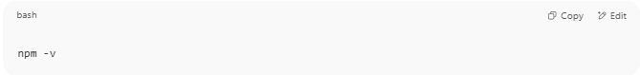
npm -v

🔧 Common npm CLI Commands
# Source: AI Source: Provided by: [Data Path: Persons Table -> ID Column: 1, Name_En Column: Motasem Essam] -> From: [Chatgpt (GPT‑5 Mini)] on [1/26/2026]
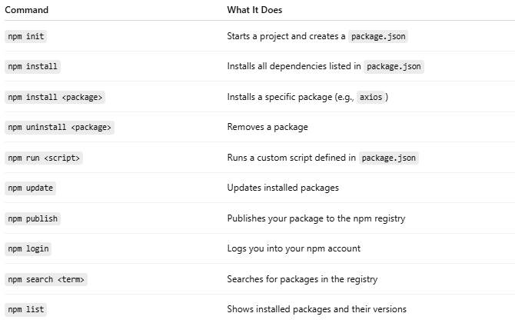
Command | What It Does
npm init | Starts a project and creates a package.json
npm install | Installs all dependencies listed in package.json
npm install <package> | Installs a specific package (e.g., axios)
npm uninstall <package> | Removes a package
npm run <script> | Runs a custom script defined in package.json
npm update | Updates installed packages
npm publish | Publishes your package to the npm registry
npm login | Logs you into your npm account
npm search <term> | Searches for packages in the registry
npm list | Shows installed packages and their versions

🧪 Example: Installing Axios
# Source: AI Source: Provided by: [Data Path: Persons Table -> ID Column: 1, Name_En Column: Motasem Essam] -> From: [Chatgpt (GPT‑5 Mini)] on [1/26/2026]
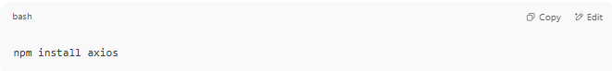
npm install axios

Creates:
- node_modules/ folder (stores the code)
- Adds axios to your package.json under "dependencies"

📁 Example Script in package.json
# Source: AI Source: Provided by: [Data Path: Persons Table -> ID Column: 1, Name_En Column: Motasem Essam] -> From: [Chatgpt (GPT‑5 Mini)] on [1/26/2026]
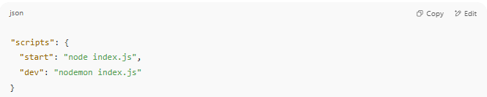
"scripts": {
"start": "node index.js",
"dev": "nodemon index.js"
}

You can run:
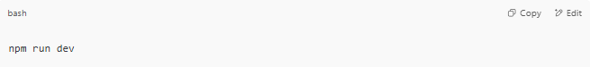
npm run dev

📌 Summary
# Source: AI Source: Provided by: [Data Path: Persons Table -> ID Column: 1, Name_En Column: Motasem Essam] -> From: [Chatgpt (GPT‑5 Mini)] on [1/26/2026]
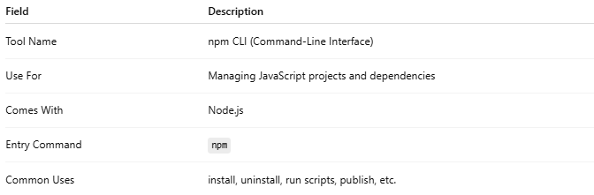
Field | Description
Tool Name | npm CLI (Command-Line Interface)
Use For | Managing JavaScript projects and dependencies
Comes With | Node.js
Entry Command | npm
Common Uses | install, uninstall, run scripts, publish, etc.

